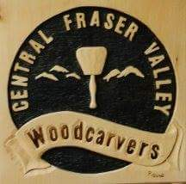

CENTRAL FRASER VALLEY WOODCARVERS
PO BOX 8000 – 408
Abbotsford, BC V2S 6H1
Pre-registration must be received by:
Friday, October 11th, 2019
Registration at Show:
Fri., Oct. 18th - 6 to 8 p.m.
Sat., Oct. 19th - 8 to 9:30 a.m.

For further information and forms:
Website: www.cfvwoodcarvers.ca
Email: cfvwoodcarvers@gmail.com
Facebook: Central Fraser Valley Woodcarvers
Twitter: @cfvwoodcarvers
Instagram: cfvwoodcarvers
After reading the Rules & Regulation and entry procedures, complete and sign this entry form:
Name: _____________________________________________________________________________________
Address: ___________________________________________________________________________________
City: __________________________________ Prov.: _______________ Postal Code: _____________________
Telephone: ____________________________________ Email: _______________________________________
I agree my entries will not be removed until directed at the end of the Show (approx. 4:30 p.m.). I certify my entries comply with the Rules & Regulations and are made by me. I absolve the Central Fraser Valley Woodcarvers of any liability for loss and/or damage to my entries during the Show.
Signature: ______________________________________

